**HOMEWORK – 5 Report**

**Osman Tunç Poyraz 150118008**

Introduction :

In this homework we are expected to build the computerized model of the system that we built the conceptual model previously. Our project is about a company that sells its own game. First of all there is required power to be able start the game which is gamePower and our customer also have their pc and they also have power, personPower. Person’s power should be higher then the gamePower if they want to play the game. Then there is servers that you can download the game from. At this servers there is capacity which limited amount of the ppl can download the game and there is also download speed that server allows which is the time that you needed to download the game. And because there is limited people can download the game at the same time there is a queue and some customers patient isn’t enough to wait for the queue. But if a customers have enough power and can wait for the queue they can wait their turn download the game and own the game afterwards.

System Definition :

Our system consists of 5 different components. These are : Main , Game , Person ,Server1 and Server2

* The purpose of **Main** component is to combine all of these components and establish relationships among them.
  + Variables :
    - *Bought the and didn’t bought the game holds the value of the customers.*
  + Events :
    - Bankrupt event -> If they couldn’t sell enough people that review the game they go bankrupt.

Finish event -> If they have enough sales and downloads which is 1500 they made their debut.

* + Parameters:
* The purpose of **Game** component is to create Game object. Customers will buy this game.
  + Parameters :
    - *Power -> Holds the gamePower value*.
* The purpose of **Person** component is to create our customers. They will come to our company and buy the Game.
  + Parameters :
    - *Patient-> Defines the patient of a customers to wait the queue.*
    - *Power-> Power of the customer’s pc.*
    - *Rate* parameter defines the advertisement effect on buying the product.
* The purpose of **Server1 and Server2** is to help the customers download the game.
  + Parameters :
    - *Capacity-> How many people at the same time can download it.*
    - *Download Time ->The time needed to download the game.*

Relations :

Our Company has its game and its servers. You need servers to download the game. And Person is our customers they come to our company with the intention of the buying the game. But the company’s conditions might not be enough to satisfy its customers.

Random Variates Generation :

The variables and The parameters is calculated by Math.Random() function which belongs to java library. And also we can control the inputs by hand with the help of sliders.

Model:

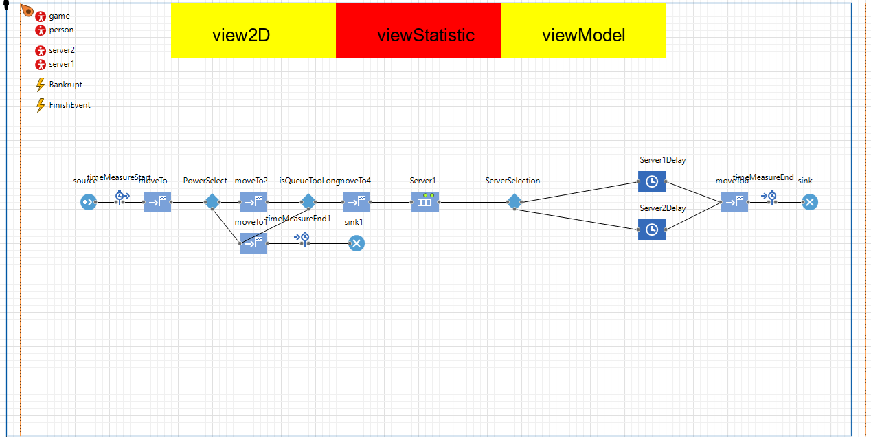

2D:

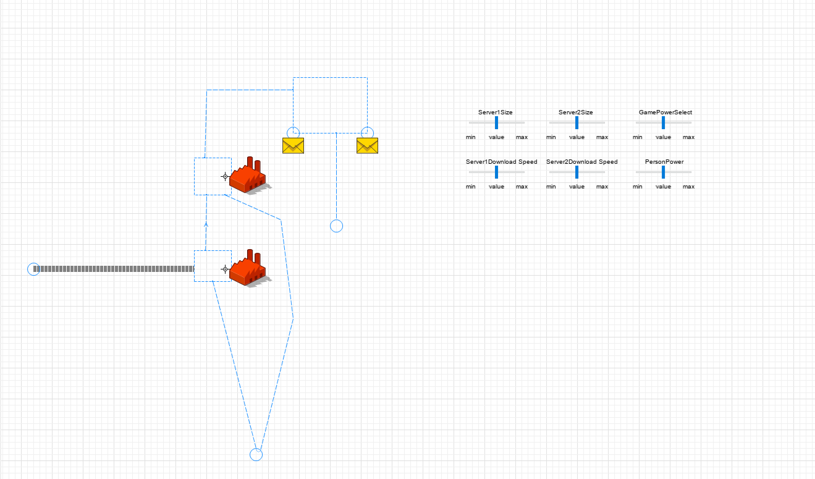

Statistic :

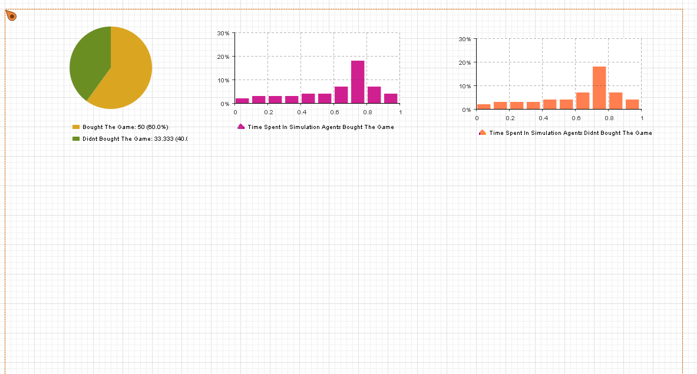

Input Variables:

The Uncontroble’s one is -> patient , type double, component : person

The rest we can control ->

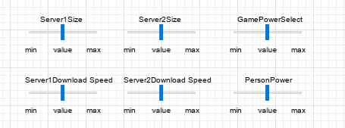

Collecting Data from output Values:

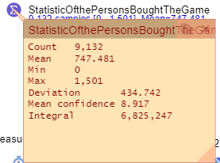

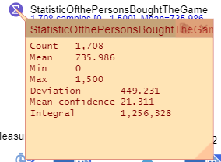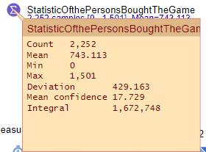

3 different tries 3 different results.

Results are pretty Different from each other